1. Save a screenshot of successfully running a website on <http://localhost:4200> . Show your website and the code terminal results

1. What is a ts file?  
   Transcript file shows the behavior of functions
2. What is the difference between an scss file and a css file?  
   scss has all of what css has and some more advanced features
3. How do you delete all of the lines using vim?  
   execute 1,$d
4. What is app.module.ts for?  
   where all the components you create can be sourced and used for the angular app
5. What does the module RouterModule do?  
   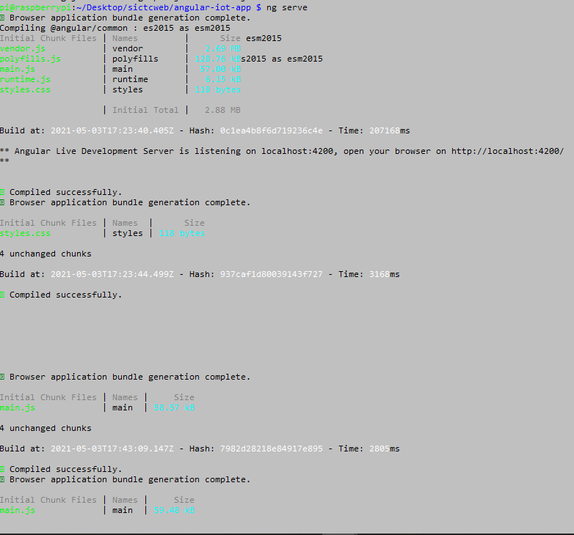
6. Take a screenshot of your home page before building a Login Page.
7. Submit a screenshot that shows the line ‘login works!’.
8. What does the code [(ngModel)] do?
9. What is the (click) comparable to in Android Studio?
10. Finish the phrase: “The more messy the code, “
11. Take a screenshot of the Create New Account button

Angular Part 2

1. What file is needed to run to make sure you can talk to your database?
2. Please explain what the method subscribe does.
3. List the steps to route data within components and Http Request?

Angular Part 3

1. Take a screenshot of the Log Out Button below the material you already created.
2. Show that you have a functional web page

Extra Challenges:

1. Make sure to check the password meets a strength requirement (same one from the final).